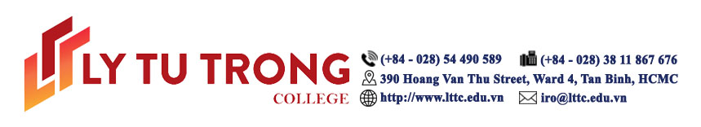

The 2018 International Conference on Smart Schools
ICSS2018 SPONSORSHIP LEVELS

Double Platinum Sponsor | $10,000
- A commercial video ad playing during conference breaks
- One full‐page ad in the conference program
- Logo on the main stage backdrop
- Logo on the red carpet sponsor wall
- Standee (0.8 m x 2 m) with corporate logo
- Three exhibit space at the Technology Showcase
- Logo on ICSS2018 website, program and other conference marketing materials
- Logo on LTTC website during 18 months
- Sponsor ribbons for your team
Platinum Sponsor | $7,000
- One full‐page ad in the conference program
- Logo on the main stage backdrop
- Logo on the red carpet sponsor wall
- Standee (0.8 m x 2 m) with corporate logo
- Two exhibit space at the Technology Showcase
- Logo on ICSS2018 website, program and other conference marketing materials
- Logo on LTTC website during 12 months
- Sponsor ribbons for your team
Gold Sponsor | $5,000
- One half‐page ad in the conference program
- Logo on the main stage backdrop
- Logo on the red carpet sponsor wall
- Standee (0.8 m x 2 m) with corporate logo
- One exhibit space at the Technology Showcase
- Logo on ICSS2018 website, program and other conference marketing materials
- Logo on LTTC website during 8 months
- Sponsor ribbons for your team
Silver Sponsor | $3,000
- One quarter‐page ad in the conference program
- Logo on the red carpet sponsor wall
- Standee (0.8 m x 2 m) with corporate logo
- One exhibit space at the Technology Showcase
- Logo on ICSS2018 website, program and other conference marketing materials
- Logo on LTTC website during 6 months
- Sponsor ribbons for your team
Bronze Sponsor | $1,000
- Logo on the red carpet sponsor wall
- Standee (0.8 m x 2 m) with corporate logo
- Logo on ICSS2018 website, program and other conference marketing materials
- Logo on LTTC website during 3 months
- Sponsor ribbons for your team

Level  Benefit | Double Platinum | Platinum | Gold | Silver | Bronze
Sponsor ribbons | • | • | • | • | •
Logo on website and program | • | • | • | • | •
Standee | • | • | • | • | •
Sponsor wall | • | • | • | • | •
Exhibit space | 3 | 2 | 1 | 1 | -
Size of ad in Program | 1 page | 1 page | ½ page | ¼ page | -
Backdrop | • | • | - | - | -
Video ad | • | - | - | - | -

